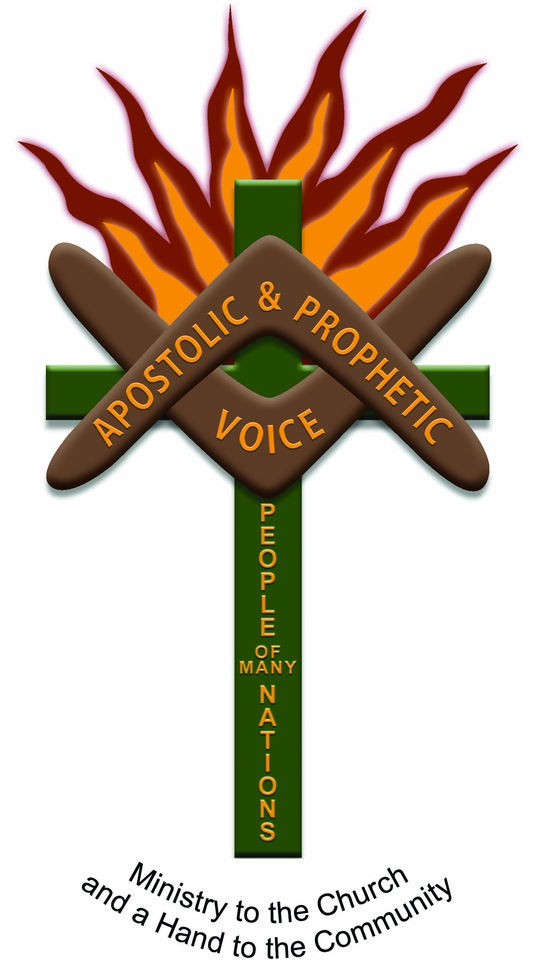


A word in Season: Proverbs 31:10 & 20

Verse 10- “Who can find a virtuous woman? For her worth is far above rubies.”

Verse 20- “She extends her hand to the poor, Yes, she reaches out her hands to the needy.”

  - UPDATE Edition MAY 2020

PO Box 3498
Toowoomba Qld 4350
Ps Ada Boland: 0499117346
Email: adaboland@outlook.com

Indigenous Apostolic

and Prophetic Voice

“HAPPY MOTHER’S DAY – CELEBRATING THE LIVES OF THE WOMEN IN OUR FAMILIES, OUR COMMUNITIES AND OUR NATION.”

2020/2021 COMING EVENTS STAY CONNECTED FOR VENUES & DATES
- REGIONAL TEAM PARTNERSHIP TRAINING 2021: If you want to be on our team let us know.
- LOCAL TRAINING & EQUIPPING: School of the Spirit – when time is permitted
- SOAR 2021 CONFERENCES: Stay connected for upcoming events (plan now to attend & partner with us to build His Kingdom on the Earth)
- Woman of Faith: Women’s Conference Fiji 2020 (be part of the team/join us) 17th-20th Sept: still happening

WHAT A beginning to 2020! Who would have thought that we would be travelling the unknown waters of difficult and uncertain times and seasons? BUT – THIS NEWSLETTER in the month ofMay is to CHAMPION and CELEBRATE the LIVES of the many WOMEN in our journey of life. Without them we would not be here today, without them we would not see the good works and heart of generosity lived out in our families, community, and our churches. Women are on the FRONTLINE making things happen and doing what they do in serving and giving and just loving out of hearts of Compassion and
Sacrificing their time, their energy and sometimes their dreams for the sake of others.
WE SALUTE YOU!
Daughters, Sisters, Mothers, Aunties, Grandmothers, Great Grandmothers, and I call you all QUEENS of the highest God, loved beyond measure.

Thank you for praying, thank you for going the extra mile, thank you for not giving up in the midst of challenges, thank you for your love and generosity.

A VIRTUOUS WOMAN, I have oftened wondered about this word and so here is what I have learnt about this particular attribute that we as women should be reflecting, living out and becoming. It means she is one who is of a good nature, a righteous character, possessing worthy and honorable traits and upright in all she does. This woman is upright and honest, and she cares more about the needs of others above herself. NO wonder she is worth more and more valuables than rubies,
Diamonds, gold and silver.
She has this unconditional love, like a mother, regardless of what we do good or not so good she still loves us. This unconditional love is what has kept a lot of sons and daughters, which I call the prodigals to come home, back to the feet of Jesus, through the hours of
Prayer and intercession from the
HEART of a MOTHER. We love you all. KEEP PRAYING FOR THE PRODIGALS TO COME HOME.
Love and Appreciation, Pastor Ada

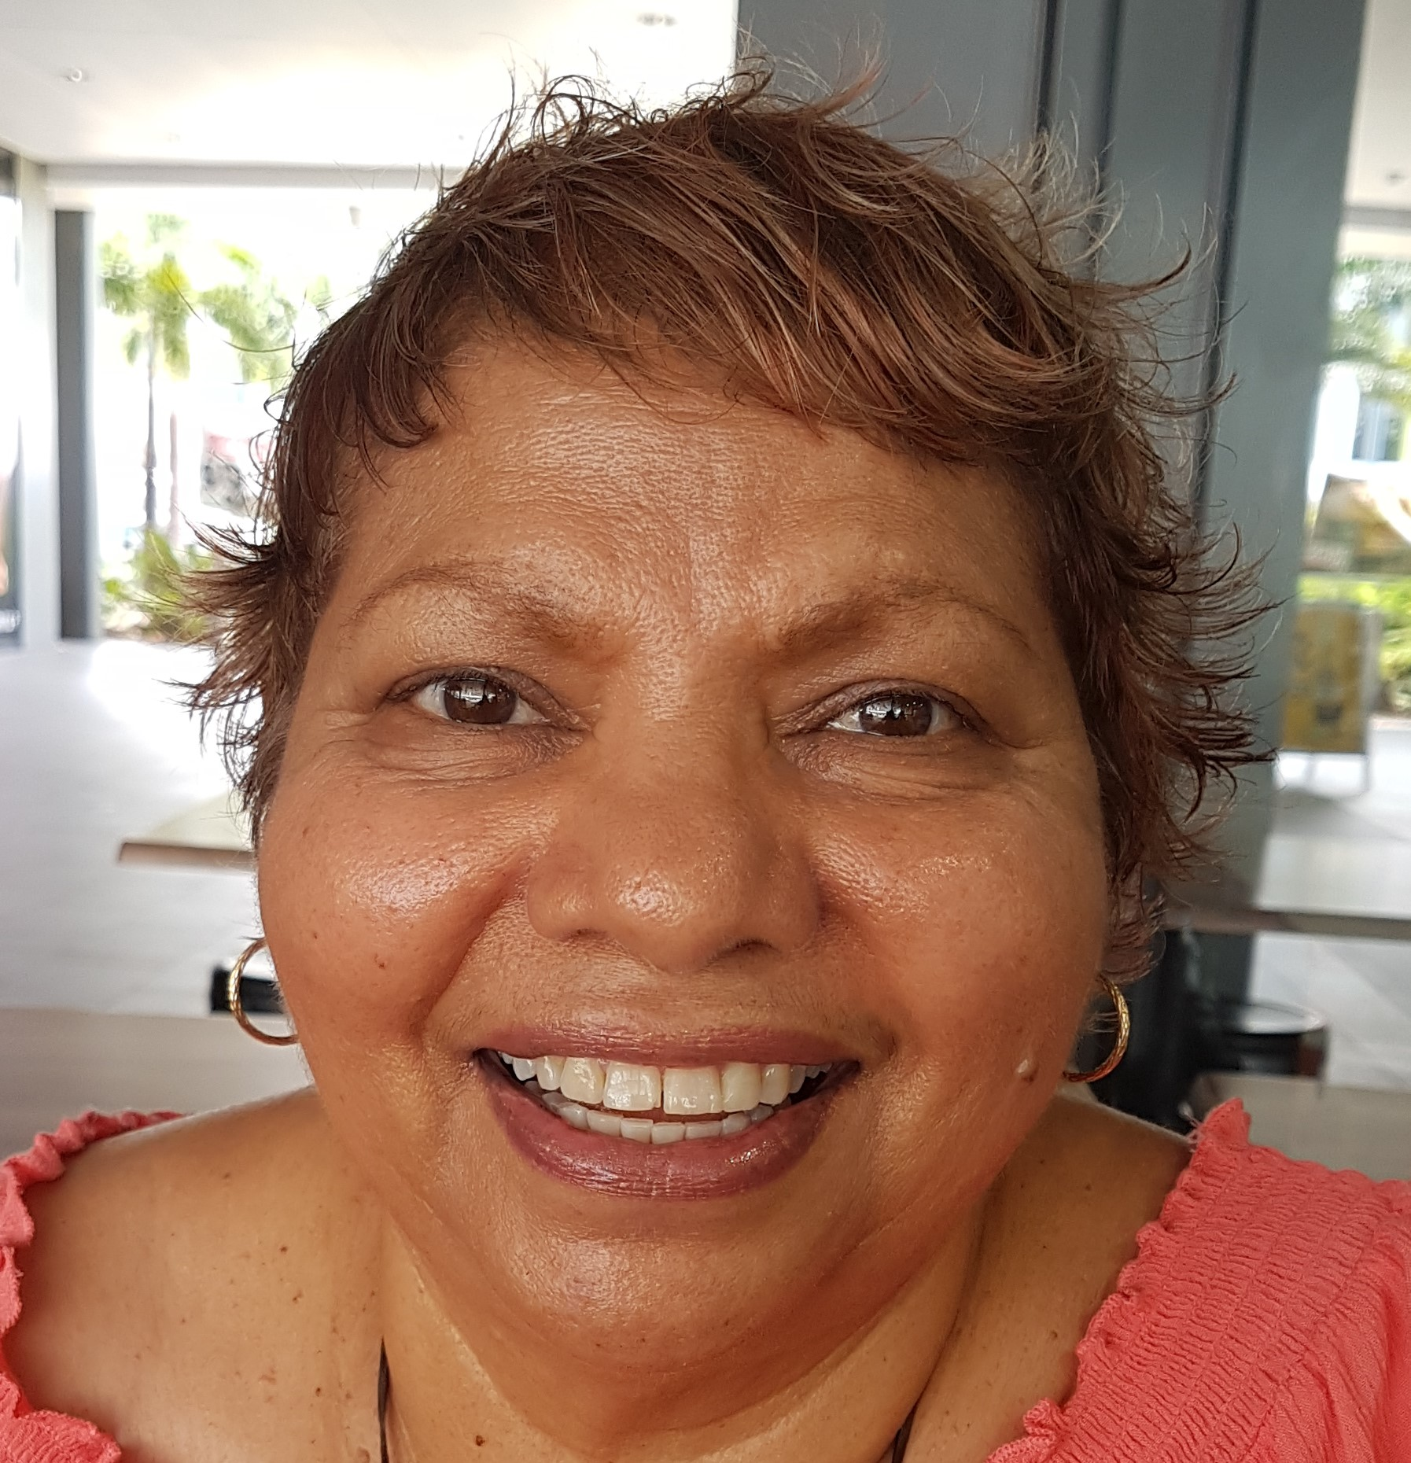

TOGETHER WE – THE CHURCH CAN MAKE A DIFFERENCE

We are looking forward with expectation & anticipation to the year ahead 2021 to see what God will unfold and what He has in store for us. If you would like to contact us regarding partnership, please give Wendy Nix Ps Ada’s (PA) a call on: 0417710418 or email: rawnix2@bigpond.com

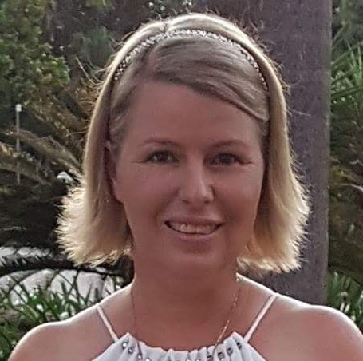

PREPARATIONS ARE UNDERWAY TO LAUNCH SCHOOL OF THE SPIRIT ONLINE. PLEASE PRAY THAT ALL WILL GO SMOOTHLY AND BE PUT IN PLACE WITHOUT ANY OPPOSITION. AMEN.

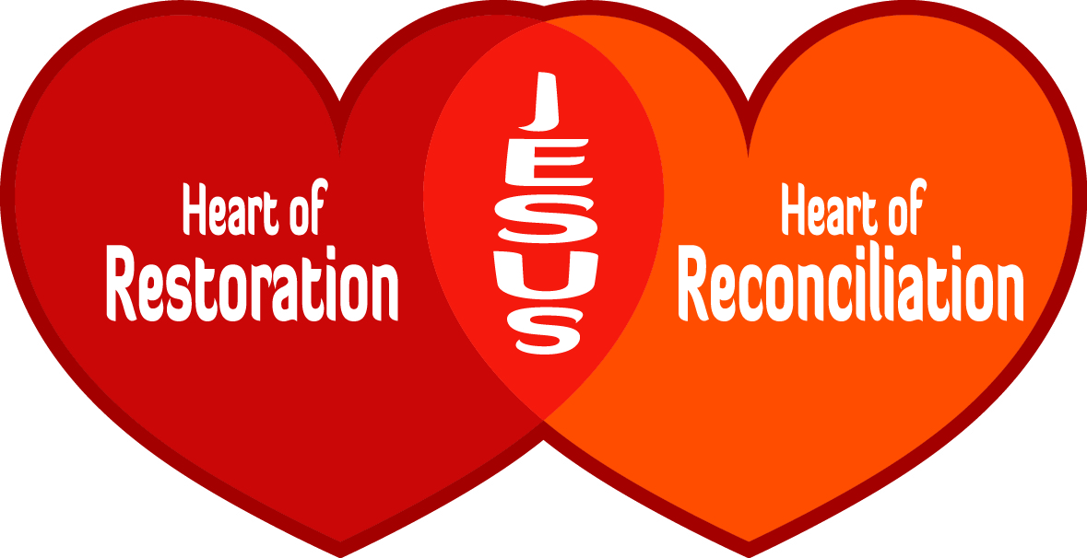

THANK YOU TO OUR PRAYER TEAM, WE ARE SO GRATEFUL FOR YOUR LOVE FOR GOD AND LOVE FOR PRAYING. A 3-FOLD CORD CANNOT BE BROKEN, WE STAND TOGETHER IN BELIEVING GOD TO LEAD & GUIDE US INTO ALL HE HAS FOR US IN REACHING OUR communities.

Prayer points
1.Please continue to cover Pastor Ada and regional teams & their leaders/families partnering with the ministry with prayers of protection and provision.
2. Now is a time of planning for the 2021 calendar for conferences, team training & equipping. In this time please pray that Ps Ada will hear from God about what He is saying regarding Strategic Places and partnerships with His Strategic Leaders.
3. Increase of Financial Partnerships & Sponsorships

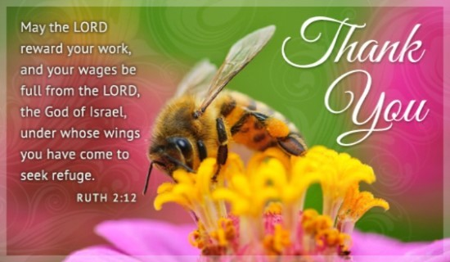

Note of thanks & appreciation

To all our Financial Supporters & Givers, we want you to know that we are standing in prayer with you, your families & ministries that God will increase the Fruits of your Hands and multiply back to you to overflowing, pressed down and shaken together with His unlimited Resources.

It is because of you all that we are where we are today, I am able to continue to do God’s work & keep my hands to the plow and not look back.

“BIG LOVE & BLESSINGS”

Thank you to all that made it happen!

School of the Spirit launched MARCH 2020 Townsville

